Assignment (4.1)

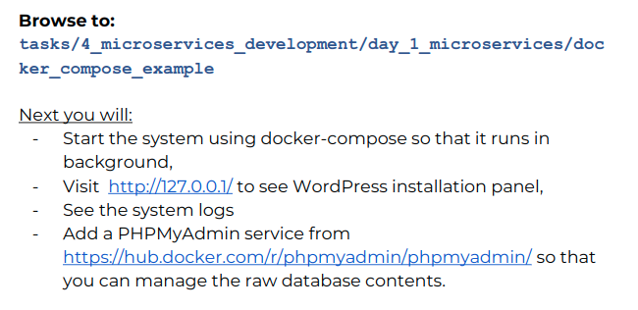

Solution

- To run compose in background we -d so the command is docker compose up -d

- WordPress installation penal is on http://127.0.0.1/.
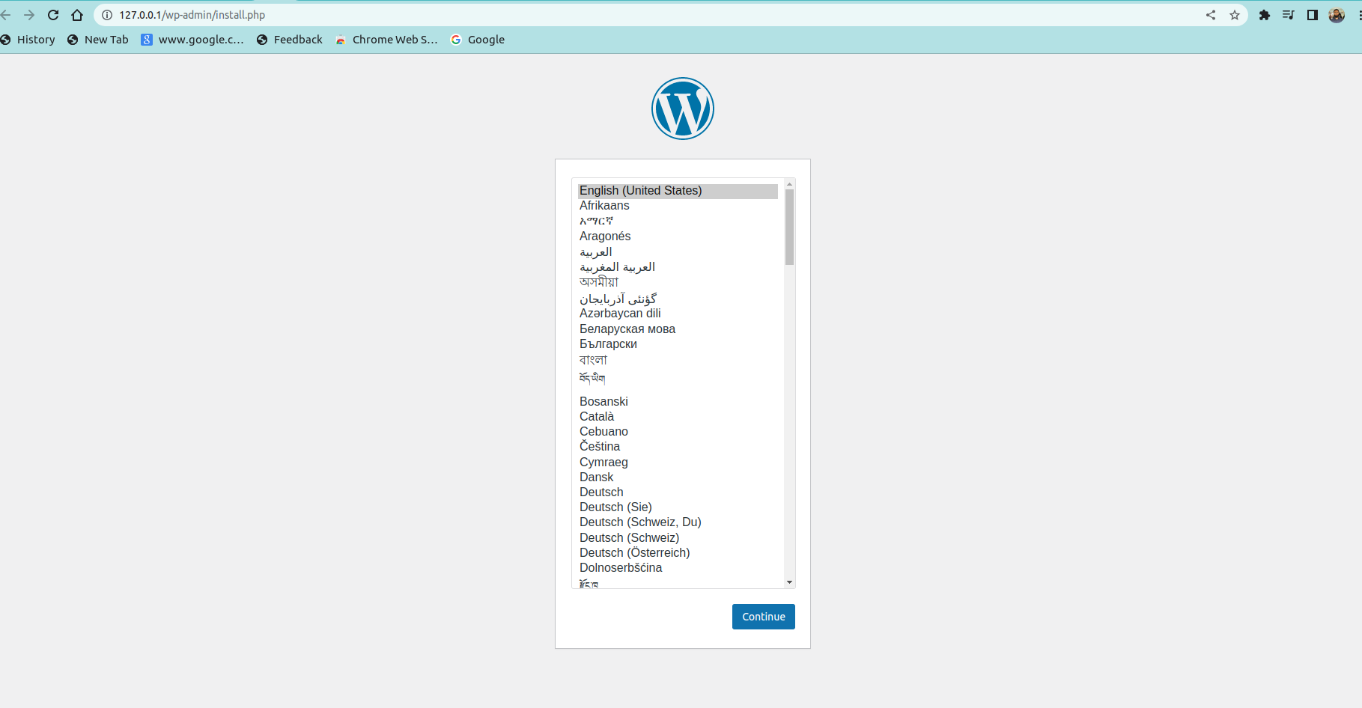

- Now we can see the system logs by docker compose logs.

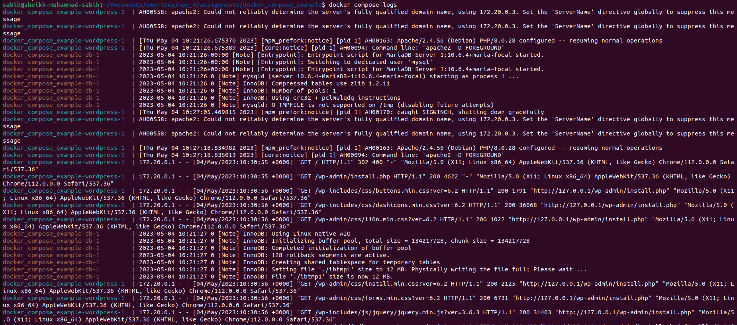

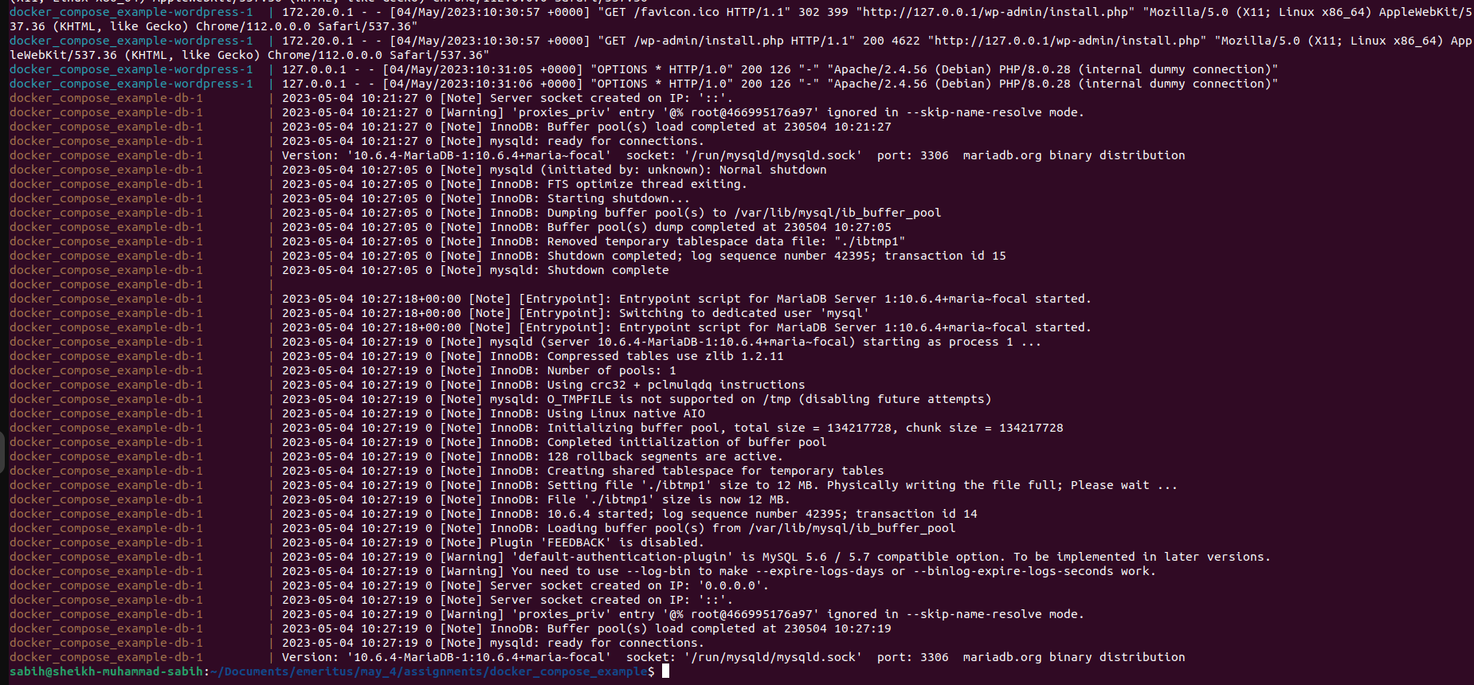

- Now we down the docker compose.

- Now we have to use PHPMyAdmin, so we edit docker compose file.
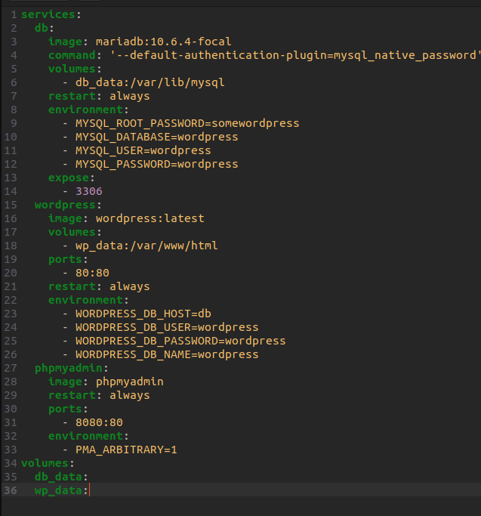
- Then we run the composer by docker composer up -d, and download phpmyadmin and run all containers.
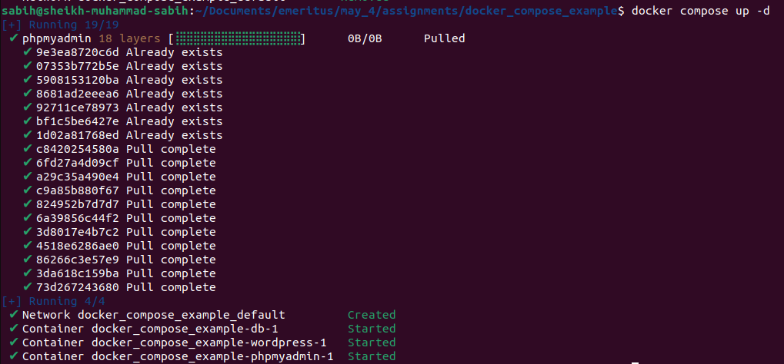

- Now we have reached the phpMyAdmin login page where we enter 'db' for the server, 'wordpress' for the username, and 'wordpress' for the password. Then we land on phpMyAdmin home page.
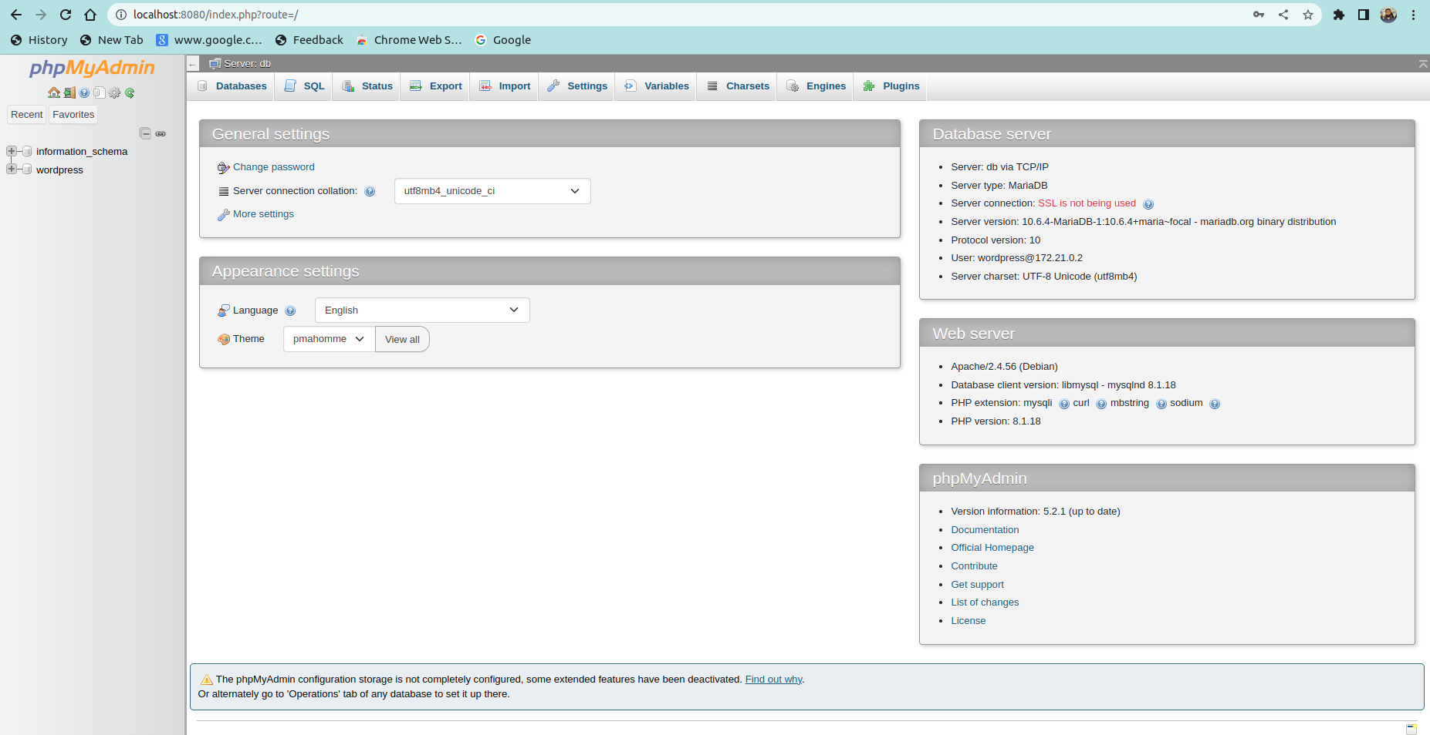
- And the logs are.


